Our Mission is
1) to REACH our world for Christ and the
church in the shortest time possible
2) to TEACH and MODEL Christ-likeness
in all we do.
Sunday School 9:30 a.m. Sunday Evening 6:00 p.m.

Morning Worship 10:40 a.m. Wednesday Evening 6:30 p.m.

Morning Worship

June 2, 2019

Sunday School Promotion

WE WELCOME YOU
Welcome/Connect Card/Information
Mission Moment
WE WORSHIP IN SONG
“You Are So Good to Me”
Greeting
“King of My Heart”
“Blessed Assurance”
(Altars are open for prayer)
“We Will Run”
WE WORSHIP IN PRAYER
Pastoral Prayer/Communion
WE WORSHIP IN THE WORD
Message: “When Life Is Unfair”
“We Will Run”

WE WORSHIP THROUGH GIVING
Scripture: Exodus 35:5a
(You may give here, on the website or the EasyTithe app)
Closing Prayer

Go out and spread the good news

Recordings of services are available at no charge. Or you can go to www.nixanazarene.org and watch the service on the website.

If you are visiting with us for the first time, please stop by the Welcome Center and sign the guest book. Don’t forget to fill out a Connect Card and drop it in the offering plate. We would like to get to know you.
OPPORTUNITIES TO SERVE
June 2nd – 9th
TODAY - Pre-Service Prayer, 9:15 a.m.
- Sunday School for all ages, 9:30 a.m.
- Sunday School Promotion, 10:35 a.m.
- Morning Communion Service, 10:40 a.m.
- VBS Workers Luncheon Meeting for all who want to volunteer.
- Small Groups, 6:00 p.m.

MONDAY - Morning Prayer Time, 9:00 a.m.
- Senior Ladies Small Group, 10:00 a.m.
- “Cup of Cold Water”, 5:15 – 8:30 p.m. We need volunteers.

TUESDAY - Men's Softball at Ozark Park, 6:00 p.m.
- VanZant Bible Study Small Group, 6:30 p.m.
- “Cup of Cold Water”, 5:15 - 8:30 p.m. We need volunteers.

WEDNESDAY - Adult Bible Study , Teen Shine, Explorers Club for K-6th grade, and Kinder Time for 3 yrs. – Pre-school, 6:30 p.m.

THURSDAY – “Cup of Cold Water”, 5:15 – 8:30 p.m. We need volunteers. Sign up at the Welcome Center.

FRIDAY - Teens Friday Night Fellowship, 7-11 p.m.

SATURDAY – “Cup of Cold Water”, 8:30 a.m. – 1:30 p.m. Help needed.
- Women’s Ministry Service Project. Marie Horne has details.

SUNDAY - Pre-Service Prayer, 9:15 a.m.
- Sunday School for all ages, 9:30 a.m.
- Morning Worship, 10:40 a.m.
- No Small Groups, 6:00 p.m.
COMING UP. . .
June 10 - Morning Prayer time, 9:00 a.m.
- Church Board Meeting, 6:30 p.m.
10 – 14 - Teen Camp #1. Cody has details.
11 - VanZant Bible Study Small Group, 6:30 p.m.
- Men’s Slow Pitch Softball game at Ozark Park, 8:00 p.m.
12 - Adult Bible Study, Teen Shine, Explorers Club for K-6th grade, and Kinder Time for 3 yrs. – Pre-school, 6:30 p.m.
13 - Lay Leadership Meeting, 6:30 p.m.
14 – 18 - Teen Camp #2. Cody has details.
15 - Pastors Welcome Class, 8:45 a.m. to noon. Please RSVP.
16 - Father's Day
- Pre-service Prayer, 9:15 a.m.
- No Sunday School but we will have a Father’s Day Breakfast, 9:30 – 10:15 a.m. All are welcome to come.
- Nursing Home Service, 10:00 a.m.
- Morning Worship, 10:40 a.m.
- No Small Groups, 6:30 p.m.
17 - Morning Prayer Time, 9:30 a.m.
18 - Van Zant Bible Study Small Group, 6:30 p.m.
- Men’s Slow Pitch Softball game at Ozark Park, 7:00 p.m.
19 - Adult Bible Study, Teen Shine, Children’s Activities for K-6th grade, and Kinder Time for 3 yrs – preschool, 6:30 p.m.

Ministry Opportunity – We are in need of a leader for our Wednesday Night Children’s Activities, beginning this Wednesday night, June 5th. The curriculum is all ready for you. If you are interested in leading this important ministry, see Carolyn Stevens, Pastor Gary or Church Office.
Upcoming
Special Events
Today
ROAR Vacation Bible School is June 24 – 27. See Amber Shelton
or call/text her at 417 425-1956, if you would like to volunteer.
Today we are having a meeting for all who would like to be a VBS worker. If you haven’t volunteered by then you can still come to
the meeting and find out where we need your help. (We are having
pizza). Pray for this Children’s Event. Pray for the workers, and pray
that God will send lots of children so we can introduce them to
Jesus.
Each year at VBS we give away 4 bicycles, 2 to visiting children and 2 to our children. We need to raise $500 to be able to do this. (We have received $50 to date). If you would like to give, note VBS on the memo of your check and place it in the offering, or if giving online VBS is an option you can choose.

June 16th
We will be serving a Father’s Day Breakfast. Bring the dad at
your house and join us from 9:30 – 10:15 a.m. for this time of
food and fellowship.

.

Nursery This Week (June 2nd)
Infant AM: Jenna Allen & Taylor Allen
KinderChurch: Debbie Shattuck
Children’s Church: Carolyn Stevens
Infants Wed: Kelly Cariker
Nursery Next Week (June 9th)
Infant AM: Madison Crawford & Amelia Sisco
KinderChurch: Jennifer Swearengin
Children’s Church: Carolyn Stevens
Infants Wed: Jenna Allen

ATTENDANCE LAST WEEK:
Sunday School - 79 AM. Worship - 99
No P.M. Service Wednesday Service - 43

FINANCIAL REPORT:
GENERAL CHURCH:
Offering last week | $5,585.05
Budgeted Expense YTD | $20,705.00
Total Received 2019-2020 | $19,267.64
OUTREACH GIVINGS:
2019-20 Faith Promise Received | $2,312.00
A.T.I.C. | $680.19
R.A.K | $833.57
Scholarship Fund | $461.86
Prayer Concerns
Bonnie Hendrix – recovery from fall
Randy Gant – health
Kathy VanZant – health
Greg and Sue Bergeson – decisions
Those recovering from storm damage
Pastor Don’s Brother Bob – Alzheimer’s
Matt Allen’s Cousin – recovery from shooting
Pat Roman’s Friend Margaret Hughs – cancer testing
Heather Haworth – cancer treatments
Lynda Crawford – surgery recovery
Ted Montgomery – shoulder surgery recovery
Kelly Rogers – June 25th back surgery
Barbara Hatem – lung cancer
Judy Davidson – cancer
Vaunda Gardner – health issues
Mike Shattuck – shoulder surgery recovery
Ralph Romig, Elsie Thompson’s son – accident recovery
Troy & Julie Brooks – health concerns
Jennifer Mercure – cancer
Alan Wood – cancer
Hazel Davis – health concerns
Houston and Vera Ker – health issues
Iris Geren – health issues
Marie Horne’s Mother – health concerns
Don Daniel’s brother – spiritual health
Pam Garton’s Brother Pat – COPD
Bert Mills – health
Jennifer Swearengin’s Cousin Beverly Stewart – cancer
Darrell Middleton – brain damage from accident
Brett Sutherland – leukemia
Keith and Cari Asby – health issues
Sean Carey – health
Scott Dooley Family – transition back to the states
Victory Mission & Least Of These – food & finance
Military Personnel
Our Leaders (Local, State, and National)
Gary Richards – accident recovery
Karri Blansit – recovery from coma

WHEN LIFE IS UNFAIR
NAHUM 1:7

BIBLICAL EXAMPLE
Exodus 1:8-14 Exodus 5:1-9
Exodus 6:1-8

LIFE ISN’T FAIR
Ecclesiastes 9:11-12
Habakkuk 3:17-18 John 16:33

GOD KNOWS AND CARES
2 Chronicles 16:9
Matthew 6:8
1 Peter 5:7
Psalm 91:1-4

Small Group Question
For June 2

- What does the word “sacrifice” mean to you?

- What are some sacrifices you have had to make in your life?

- Does God expect us to sacrifices? (see Romans 12:1)

- What ministry of the church are you willing to make sacrifices to serve?

- How can we allow God to help us with the unfair things in life?

- Will we allow ourselves to find hope in the promises of God? Name one of your favorite promises.

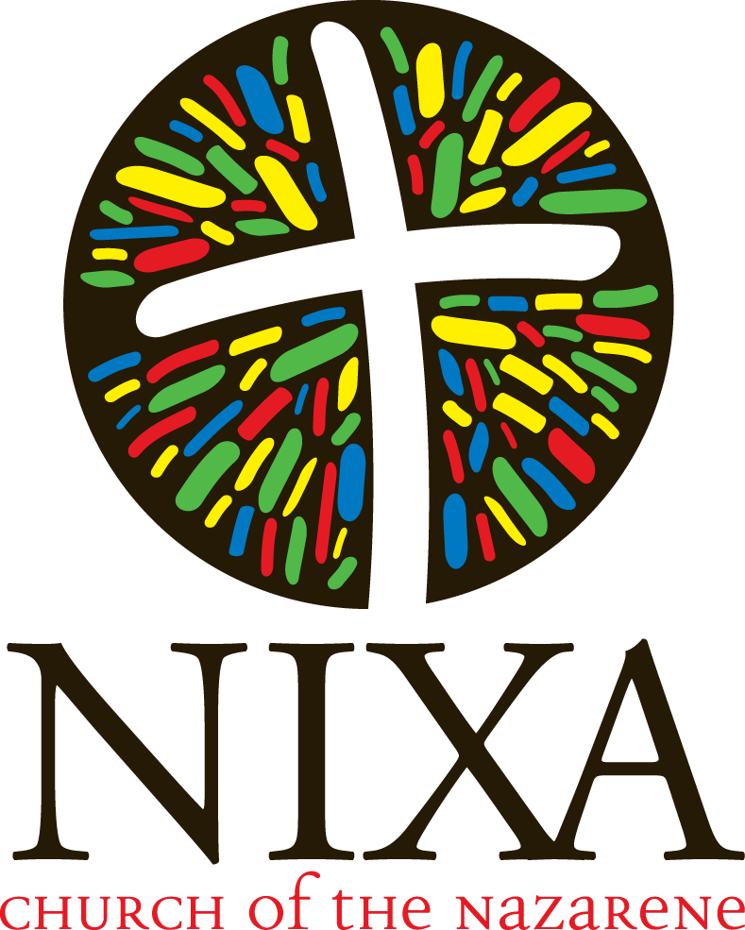

306 Northview Road
Nixa, MO 65714
417-725-4224 or 417 725-4293
Email: office@nixanazarene.org
www.nixanazarene.org

Sunday School: 9:30 a.m.
Sunday Worship: 10:40 a.m.
Sunday Evening Worship: 6:00 p.m.
Wednesday Services: 6:30 p.m.

Gary Swearengin, Pastor
Don Daniel, Associate Pastor
David Sutton, Associate Pastor

